# Author: Bedemariam Degef

# Date; March 7, 2020

# Python Flask and Puzzles

Figure 1 Login page

Figure 2 Testing: login page with the wrong credentials

Figure 3 (Second page) Testing: logging in with a password in the database but a common password

Figure 4 Testing: logging in with a password in the database but a too short password

Figure 5 Testing: logging in with a password in the database but a too long password

Figure 6 Testing: trying to update a password with a new common password

Figure 7 Testing: trying to update a password with a new too long password

Figure 8 Testing: trying to update password with a new too short password

Figure 9 Testing: Successful password update

Figure 10 Testing: Before and after the update

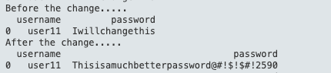

Figure 11 Testing: disabling after 15 failed login attempts by the same ip address

Figure 12 Resetting limitation after successful login

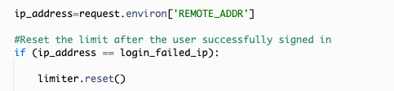

Figure 13 Testing: Logger

Figure 14 Testing: Logger analyzer

**PUZZLE**

a) Morse code was used to encode the message, and it is decoded below

**S HAS SOME STRANGE REQUESTS**

b) Base64 was used to encode the message, and it is decoded below

**So this is base64. Now I know.**

c) This one was amazing I tried almost all the decoding algorithms, but they didn’t work. Finally, I had experience with caesarian shifts and first tried it in my head by shifting each letter but couldn’t figure it out. However, I tried a higher shit on the website and to my delightful surprise it worked.

Caesarian shift was used to decode the message, and it is decoded bellow.

**--- Begin Key ----**

**I am so clever. No one could possibly figure this out.**

**--- End Key ---**

